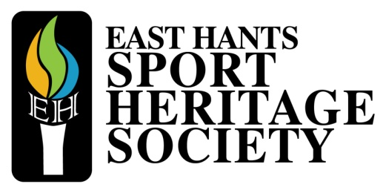

East Hants Sport Awards
The East Hants Sport Heritage Society is proud to launch the 6th annual East Hants Sport Awards. The awards will recognize the sport excellence within the Municipality by celebrating our best and brightest of 2019.
Eleven awards will be given out to recognize individual athletes and teams across all ages, as well as coaches and volunteers for their extraordinary efforts in their respective sport(s).
Winners will be announced at an evening gala event held on May 23rd, 2020 at the Riverside Education Centre.
Award Categories:
14 & Under Division:
- Top Female Athlete
- Top Male Athlete
- Top Team
18 & Under (15-18 yrs.)
- Top Female Athlete
- Top Male Athlete
- Top Team
19 & Over Division:
- Top Female Athlete
- Top Male Athlete
- Top Team
Top Coach and Volunteer of 2019

Award Criteria:
- The nominee must either be a resident of the Municipality of East Hants or play their respective sport(s) within a club or team based in the Municipality.
- The 2020 awards ceremony is recognizing achievement during 2019. Nominees must have completed their season before December 31, 2019. In the case of sports that have overlapping years (i.e. hockey/basketball) the season of 2018-2019 is eligible.
- The nominee must be in good standing with their respective sport association either locally or provincially.
- A nominee’s category for the award is based on their age as of January 1, 2019.
Submission Details:
- The deadline is Tuesday March 31st, 2020 at midnight.
- Please fill out the form below and provide a point form summary outlining major achievements, statistics, and awards of the nominee. Maximum one (1) page. One (1) additional page may be provided to support and demonstrate the exceptional season (i.e. newspaper clippings, statistics, etc.) Submissions will not be returned so please do not provide original copies of valuable documents or support evidence. Copies are accepted.
- In addition to the completed application, nominees must also include a minimum of 3 high resolution photos which will be used at the Sport Awards or for media purposes if the nominee is selected as a finalist
- Submission documents must be sent as a word document via email to info@easthantssportheritage.com or as a printed, stapled package by mail to the East Hants Sport Heritage Society at: P.O. Box 280, 5 Mill Village Road, Shubenacadie Professional Center, Shubenacadie, NS B0N 2H0
- The awards committee will only take into consideration nominee information that is provided on the form and supporting documents.
- All submissions will be evaluated by the East Hants Sport Awards Committee

Three nominees will be selected in each category to attend the East Hants Sport Awards event held in May. Winners will be announced at the gala event. Selected nominees will be contacted prior to the event.

ATHLETE NOMINATION FORM

INFORMATION ABOUT NOMINEE
Nominated for participating in the following sport(s)
Full Name of Nominee:
First |  |  |  | Last |  |  |  | Initial |  | Male Female
Address: |  |  |  |  |  |  |  | Apartment/Unit #
 |  |  |  |  |  |  |  | Prov | Postal Code
Home Phone: | ( ) |  |  | Alternative  Phone: |  |  | ( )
Email address: |  |  |  | Please check which nomination category the nominee would be eligible for  14 & under 18 & Under (15-18 yrs.) 19 & Older
Family Contact:
Address: |  |  |  |  |  |  |  | Apartment/Unit #
 |  |  |  |  |  |  |  | Prov | Postal Code
Home Phone: | ( ) |  |  | Alternative Phone: |  |  | ( )

INFORMATION ABOUT NOMINATING PERSON OR GROUP
Name of Person or Group Submitting Nomination:
Address: |  |  |  |  |  |  |  | Apartment/Unit #
 |  |  |  |  |  |  |  | Prov | Postal Code
Home Phone: | ( ) |  |  | Alternative Phone: |  | ( ) |  | Email
Contact:  (If different from above) |  |  |  |  | Home Phone: |  |  | AlternativePhone:
I give permission to the East Hants Sport Heritage Society to use the information contained in this nomination for research purposes YES NO

In the page below outline the major accomplishments of the nominated athlete. This includes major awards, relevant statistics, records, championships, medals. What they’ve done for their respective team or sport, etc. Please use point form. (One page maximum, 12 point font minimum)

